** SOHAIB ANJUM 65309**

**PAF-Karachi Institute of Economics and Technology College of Computing and Information Sciences**

DATA COMMUNICATION & NETWORKING-111732

**Assignment – 1**

**\*IMPORTANT INSTRUCTIONS:**

**Read the following Instructions carefully:**

* Attempt all questions.
* Add screenshot of each question’s solution with output.
* Try all the questions yourself. If the solution is copied, the task will be marked as ZERO.
* Arrange questions and their subsequent parts in sequence.
* Deadline 14-Apr-2023.
* Save your word document with name: [Student Name Student ID].

**[5 mark]**

**Q1.** Design a network which consists of 4 routers and 3 PC’s are attached with each of them. Different users want to access the attached routers but unable to do that. You have to resolve this problem so that the devices can establish the TELNET session with the routers 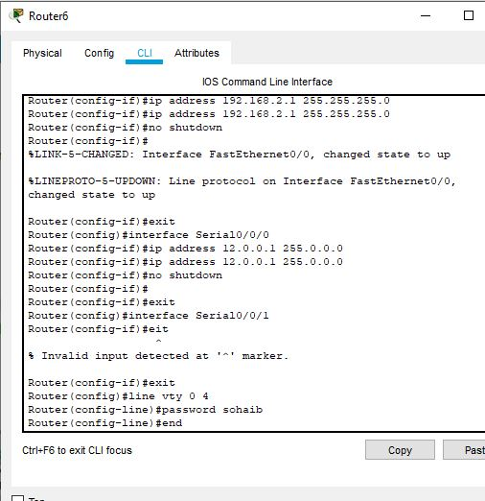

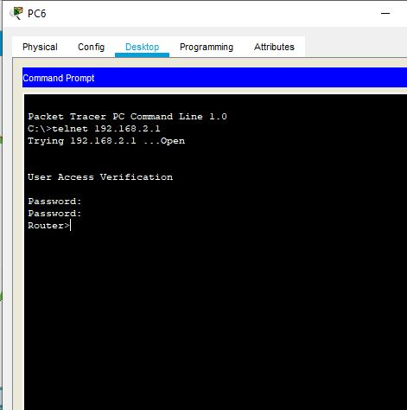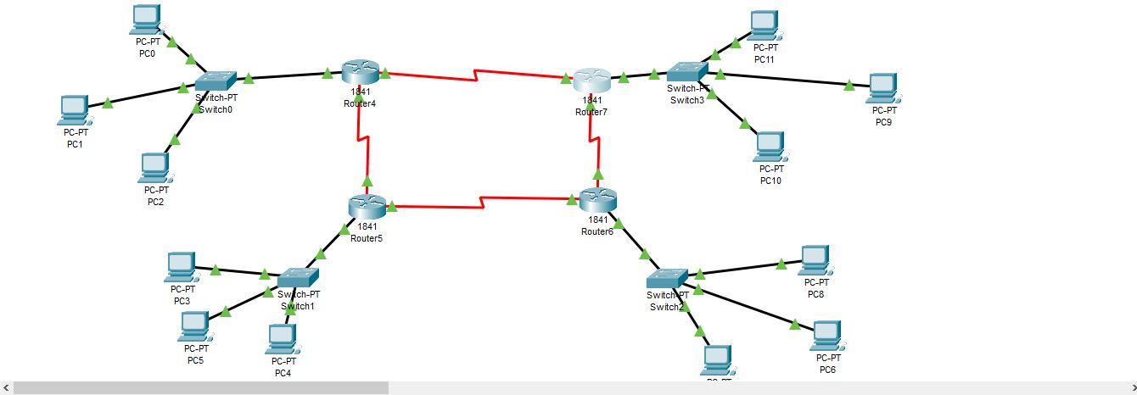

**[5 mark]**

**Q2.** Design a Mesh network which consists of 4 routers. Use serial cable between routers. Attach a single PC with each router. You have to establish TELNET session by setting all three passwords which should be on student name plus ID. 